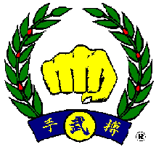
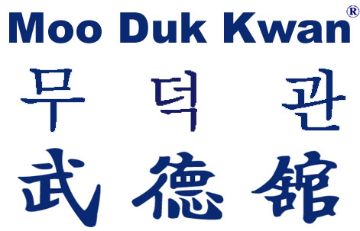

2013 WORLD MOO DUK KWAN SYMPOSIUM
It is the time again that the National Organizations’ Designees begin preparing for the WMDK Symposium – a Celebration. The 2013 Symposium will begin with check-in on the day of 30 October 2013 followed by dinner at 6:00 PM and then the opening of the Symposium at a meeting that evening at 7:30 PM. The Symposium will adjourn in the evening of 3 November. A breakfast will be provided the morning of 4 November.
This year we will be the guests of the Greek Federation in Athens. The Greek Federation will provide you all with information regarding the location of our meetings, the hotel and eating arrangements, the ground transportation arrangements and any costs associated with them.
As we prepare for the Symposium, it is critical that each Designee read the 2012 Minutes and familiarize themselves with the Agenda Items that were discussed by the Zone Designees and the decisions that were made. If there are any questions, please contact your Zone Designee who was at the 2012 Symposium representing you, your member schools and your members.
The 2012 Minutes contain a section at the end which includes four Attachments. These Attachments present: #1 RESPONSIBILITIES OF MEMBER COUNTRIES; #2 WORLD MOO DUK KWAN STATEMENT OF PURPOSE; #3 NATIONAL DESIGNEE RESPONSIBILITIES; #4 ZONE LOCATIONS. It also lists the WMDK ACTIVITIES, which are the benefits of belonging to, and supporting, the WMDK. This is intended to guide the Designees and National Organizations in performing their responsibilities related to their positions in the WMDK.
The President has stated that all National Organizations need representation of a Designee at the Symposium. If it is impossible for the Appointed Designee to attend, he/she will appoint an Alternate Designee to represent their National Organization. The Proxy option will be used only when a last minute incident makes it impossible for the Designee to attend, and that Proxy must be given to a Designee from another nation who will be at the meeting.
The President also noted that last year we held the Zone meeting and there was no representation from Zone 3 which includes 11 countries. That means that 11 countries did not have representation.
The President has identified some important Agenda items for this year’s Symposium which are listed as follows:
1 -- A DISCUSSION OF THE PROGRESS OF EACH NATIONAL ORGANIZATION IN MEETING THE CRITERIA OF THE WMDK INTELLECTUAL PROPERTY REGISTRATION AND PROTECTION.
2 – A DISCUSSION OF HOW EACH NATIONAL ORGANIZATION IS PROMOTING AND DEVELOPING THE YOUNG LEADERS PROGRAM (the future of the WMDK) IN THEIR AREA.
3 – UPDATE OF THE SOO BAHK DO INSTITUE
4 – UPDATE OF THE WMDK WEBSITE AND PLANS FOR THE FUTURE
5 – PROGRESS MADE BY EACH NATIONAL ORGANIZATION IN THE STANDARDIZATION OF THE JO KYO, KYO SA AND SA BOM CERTIFICATION PROCESS AND REQUIREMENTS
6 – FUTURE SYMPOSIA
7 – PREPARATION FOR THE 2015, 70TH CELEBRATION IN KOREA
8 – NEW BUSINESS
As noted, these are the Agenda Items that the President has identified. Of equal importance are the Agenda items that each Designee submits to be included in the Symposium which represents their members and National Organizations. So it is important that we receive these Agenda Items by 15 September so that they can be included in the Final Agenda which will be submitted to all Designees several days later. This is both an opportunity for, and a responsibility of, the National Designees.
Please submit all Agenda Items to me by email and I will ensure that they are part of the Final Agenda. If I have any questions I will email them to you immediately.
We expect that this Celebration will be an enjoyable opportunity for all to make meaningful decisions that will influence the future of the WMDK, to train together in our Art, and to celebrate our meeting in social settings including a tour of the area.
If you have any questions or comments regarding this communication, please email me and I will respond immediately.
Thank you all for your commitment to the WMDK and our Art of Soo Bahk Do.
Respectfully submitted,
Lawrence Seiberlich, Chair

