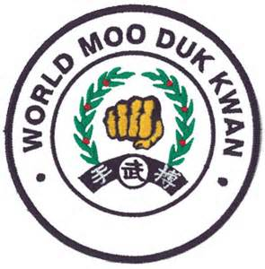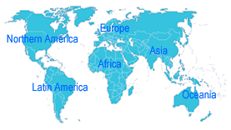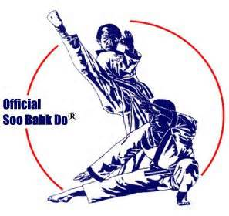

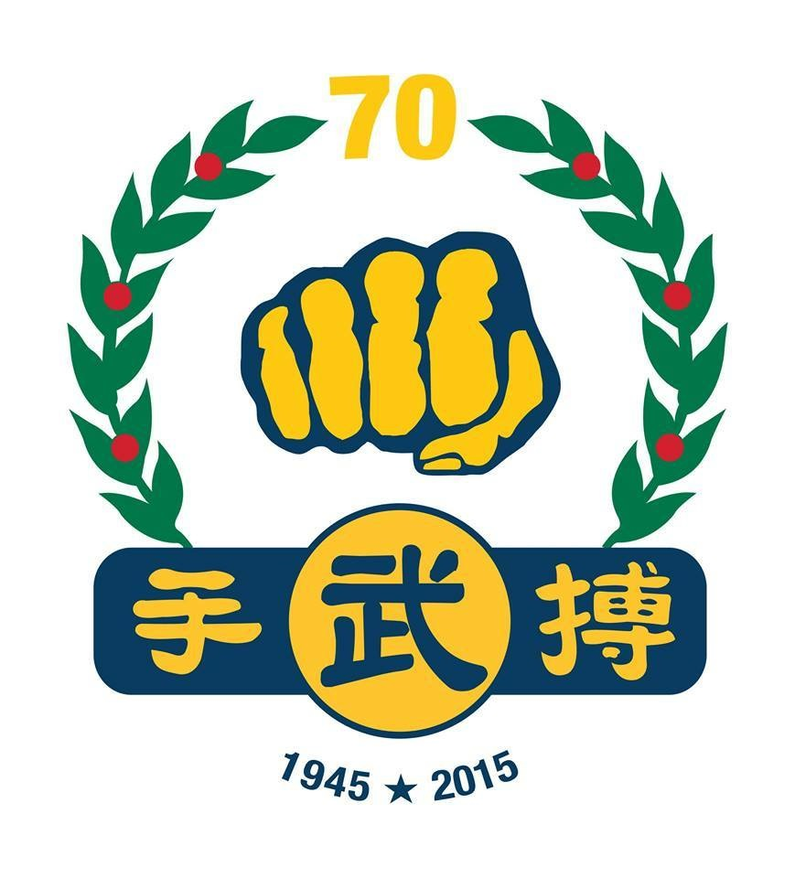

Minutes of the 2015

WORLD MOO DUK KWAN SYMPOSIUM,
Ganghwagun, Korea

DATE: 26 -29 Oct, 2015

PRESENT:

H.C. Hwang, KJN; President, WMDK
Lawrence Seiberlich, SBN; Chairman, WMDK Symposium
Ramiro Guzman, SBN; Mexico Designee and Hispanic Interpreter
Francisco Blotta, SBN; Argentina Designee
Cash Cooper, SBN; USA Designee
Peter Kidd, SBN; UK Designee
Kriton Glenn, SBN Australia Designee and Vice Chairman, 2015 WMDK Symposium
Mo Vatan, SBN; Iran Designee and Secretary, 2015 WMDK Symposium
Roberto Fontora, SBN; Uruguay Designee
Joe Scholz, SBN, USA; Communications – IT
Alex Carrillo Sanhuezo, Master; Chile Designee
Diego Salinas, SBN; Spain Designee
Cesar Rodriguez, SBN; Iceland Designee
Elodie Mollet, SBN and Kyo Sa Angnes Torresi; France Designees
John Lynch and Jim Class, Masters; Puerto Rico Designees

The 2015 WMDK Symposium was a Meeting of all Designees and 70th Anniversary Celebration

Agenda Item | Action | By Whom | Review Date | Resolved
1st Session, 26 October, 2015 (7:30 pm to 8:30 pm) all present

Ken Trevilan, SBN substituting for Cash Cooper, SBN as USA Designee
Angnes Torresi, Kyo Sa substituting for Elodie Mollet, SBN (KDJSS Candidate) as France Designee

Formal opening  And  The President Welcome  Remarks | Formal opening ceremony  The WMDK President officially opened the 2015 WMDK Symposium.  The President welcomed all participants to the 2015 Symposium.  The President gave special thanks to Seiberlich SBN and the Designees for their attendance.  The President pointed out the historical importance of this year, celebrating the 70th anniversary of the MDK. He emphasized that only with participation, can we achieve our goals and strengthen our five Moo Do values. | The President
Appointments | Appointments for the Symposium 2015  - Seiberlich, SBN Chairman  - Glenn, SBN Vice Chairman  - Vatan, SBN Secretary  The President excused himself from the meeting. | President
The Chairman  Welcome Remarks | .  • The Chairman welcomed all to the meeting and asked participants to introduce themselves and identify which Countries they represent.  • After introduction of the Designees, the Chairman thanked everyone and stated the significance of 2015 Symposium with the 70th Anniversary Celebration.  • The Chairman mentioned that the WMDK has 26 member nations, but we have only 12 designees attending with 5 Proxies. The 9 countries with no Designee or Proxy are left without a voice in the future of WMDK, but still have a responsibility for decisions made on their behalf, so they should be informed of the results of this meeting.  • Each Designee is responsible for representing the concerns of all members, and each member is responsible for communicating concerns to their Designee, especially at biannual zone meetings. The Designee’s most important role is to share the minutes with their members and discuss the information.  • Each member is encouraged to reflect on why he/she initially became interested in the Moo Duk Kwan and why he/she is currently a member. Each member must uphold the Moo Duk Kwan identity to their own countries.  • I want everyone to remember that if they receive an email from Dan Ellenbacker, SBN (dellenbacker@Gmail.Com), he is my assistant. The mail is coming from the Chair. Please respond and confirm by email, the receipt of this email so we know who may not have received it.  Note: Chairman's remarks occurred in various Sessions. | Chairman
Concept of Unity | Secretary read the Concept of unity.  "The Federation's purpose is to prepare a home in the United States for a Unified World Moo Duk Kwan assembly. It must earn the right and privilege of having many Master's Dans and Gups, who study Soo Bahk Do, as its membership.  As a vehicle that promulgates the Korean Martial Art of Soo Bahk Do, it must keep developing the environment, atmosphere and respectability that will encourage many individuals to join in this unification effort and process.  The home that is being built must be a warm, comfortable and peaceful place that can be respected by all the World Moo Duk Kwan stylists. It should have the ability to understand and serve each member's needs.  The present Federation members are the carpenters of this home. if the job is well done, tenants will surely move in and the World Moo Duk Kwan assembly will finally have a home in the World other than in their minds and hearts" | Secretary
 | Formal closing ceremony 1st Session
2nd Session | Opening the 2nd Session, 27 Oct, 2015, 9:00AM  All present, except for the President who was with other actives of 70th celebration agenda.  Formal opening ceremony.
ITEM #1: Resolution of the legal action

ITEM #1 | The Chairman discussed the resolution of the legal action that the Soo Bahk Do Moo Duk Kwan Federation filed in Federal Court against an organization in the United States that had infringed upon its trademark, the name of the registered property of the U.S. Federation. Key words are “in the United States,” “by the U.S. Federation,” “against an organization operating in the United States,” and other key words are “trademark infringement and name.”  The verdict and a judgement of $115,560.0 in damages was filed in favor of the Plaintiff, the US Federation. This stands as an example that the U.S. federation will challenge all infringements as they have over the past 30 years, and they will prevail. This action and verdict is a victory for all WMDK organizations and sends a clear message to those who wish to infringe upon their intellectual property.  The judgement that’s been laid out by the Federal Court sets down precedence. It means that that other national organizations may use that same verdict in order to defend their IP when infringed upon in the same context, because other courts tend to respect precedents.  Item completed. | Chairman |  | Yes
Minutes of the 2014 Symposium | Minutes of the 2014 Symposium  Last year’s Minutes were provided to all Designees although some of the Designees said that for one reason or another they have not received the Minutes. A copy of the 2015 Minutes was passed to everyone to review, and to be discussed at a later Session.  The Chairman expressed that the acceptance of the Minutes from the Zone meeting can only be done by people who were there. So people who were at the zone meeting can say it is a true reflection of what was said.  In the afternoon Session of the same day the Minutes of the 2015 Zone Symposium were passed unanimously.  Vote: In favor = Unanimous; Motion passed.  Formal closing ceremony 2nd Session, 12:05 Pm | Chairman  Moved by  Glenn SBN  Seconded by Guzman SBN |  | Yes
3rd Session | Opening the 3rd Session, 27 Oct, 2015, 2:00 PM
Item #2: Licensing and protection of intellectual property

Item #2  Item #2 | The Chairman asked the Designees to look at the licensing and protection of intellectual property, and the benefits and responsibilities involved. Each country must pursue the registration of intellectual property related to their own laws, and Kwan Jang Nim has expressed strongly that this registration is fundamental to a national organization’s operational procedure.  It is critical that each national organization work to register their intellectual property.  And, each national organization must pay an annual fee to the WMDK for the use of the intellectual property. The World Moo Duk Kwan has yet to receive a license fee payment from some of its members.  Those who have submitted a license fee for the use of the intellectual property are Australia, Iran, Korea, Puerto Rice, Switzerland, the United States, and Mexico. Kwan Jang Nim expects that the other national organizations will submit the required fee in order to hold their IP license. This amount, set at the Zone meeting in Ramona, California three years ago by Kwan Jang Nim, was $10 per member/year.  Spain, Mexico and Argentina expressed that they have legal issues in their country regarding the transfer of money and/or exchange of the national currency for the U.S. dollar.  After some discussions, the Chairman noted that it is up to each country to honor its agreement, and how they actualize their agreement is between the individual country and the World Moo Duk Kwan. The relationship between the national organization and the World Moo Duk Kwan is a two-way street, compare it, by analogy, to the relationship between student and teacher.  The problems related to the transfer of funds fall into several categories. The national organizations, not the World Moo Duk Kwan, must solve these problems but the WMDK will work with each national organization to help them work through the porblems.  The Chairman listed the benefit each member is receiving for submission of this annual fee:  1. Promotion  2. Testing  3. Teaching Certification  4. Seminars  5. On-line curriculum  6. Printed materials  7. Access to Kwan Jang Nim  8. Legitimacy  9. Real Membership in an official Soo Bahk Do Moo Duk Kwan organization  10. Membership in the WMDK  11. Use of name  Chile suggested paying the fee by PayPal.  Another issue related to Item #2 was discussed – how should each national organization provide student information to the WMDK, and what info should be provided considering various privacy considerations? After some discussion, the Chairman noted that all Designees agreed to provide only name, rank, Gup or Dan numbers and instructor’s name. Glenn, SBN has provided copy to everyone a sample to use and he will email to all.  The WMDK contends that more information will be required for basic communication and record keeping. This Item needs further investigation and resolution.  Item continued for further discussion. | Chairman  Chairman |  | Open  Open
Item #3: WMDK Documents (Agreements)

Item #3 | The chairman excused himself and asked the Vice Chair to start Item #3.  The Vice Chair stated that it is our responsibility when we come here, to have the authorization to represent the position of our national organization which we represent. This is very important item related to the organization’s Agreement with the WMDK. There are two different components of the Agreement documents, one is the document itself which is to be signed, but there are also some supportive documents or attachments. For example, one is the Organization’s constitution. The WMDK understands that some Designees have submitted some documents, some have the appropriately signed documents, and some are yet to contribute anything.  The Vice Chair said that only authorized individuals can sign forms that relate to licensing and registration and that documentation should include the national organization’s legal status within that country, and identify that organization’s relationship with the World Moo Duk Kwan as licensor.  He discussed this with the Designees and asked them if they all had completed the Agreement documents. He then distributed Agreement documents to Designees that did not have them or had not filled them out, to review. The Designees who had not yet submitted the appropriate Agreements should sign and submit the documents to the World Moo Duk Kwan by the end of August 2016.  The Vice Chairman indicated that the documents are on the WMDK Website.  All signed documents shall be sent to Scholz, SBN at Scholzjo@Gmail.Com and he will put them in one package and will send it to the WMDK. If documents need translation an attachment should be done by an official translator and notarized so that it has legal validity; However, The WMDK has established English as the language of the World Moo Duk Kwan Business. Some of the nations have signed and submitted the Agreement documents during the Symposium. Scholz, SBN will create a list of the countries that signed and completed the documents. Formal closing ceremony 3rd Session, 5:00 PM | Vice  Chairman |  | Open
4th Session | Opening the 4th Session, 28 Oct, 2015, 9:00 AM
Item #4: Moo Do Value Based Sparring

Item #4 | Chairman has returned  The Chairman indicated that there will be a training session related to Moo Do Value Based Sparring. It was “moderately successful” last year at the US national tournament in Boston. The most important outcome of the training is fair and accurate judging. The Chairman asked if everyone knew about MDVBS and had received the material sheets sent by Cooper, SBN via email two months earlier.  Some have not received this email and the Chairman said Designees must confirm receipt of emails / documents so the sender will know who has received and who has not.  He mentioned that in MDVBS, "Objective judgement for officials is one of the most important things to promote good competition. Judges need to be “very observant and well-trained.” In Boston, there was too much emphasis on attacking rather than defense. Junior members tend to emphasize attacking and Senior members are generally more calm, patient, and emphasize defense.  The Chairman asked the Vice Chairman to discuss Items #4, #6 and #9; and he excused himself from the meeting. Vice Chair asked everyone to become informed about the MDVBS method and provide some feedback. He read some of the feedback that he has received from Australia and other national organizations.  Also, he suggested that the Designees run a MDVBS seminar, or clinic, or special training session, before Christmas, in their own country.  Vote: In favor = Unanimous; Motion passed.  Item completed | Chairman  &  Vice Chairman  Moved by  Guzman SBN  Seconded by Cooper SBN |  | Yes
Item #5: PVT-2 Tour and Young Leadership Program

Item #5 | The President attended this meeting.  The President’s remarks:  We all know this is an extremely important issue, particularly for this moment and for this time. Late in the 60s and 70s many of the young instructors supported the Moo Duk Kwan and set a very good standard and we are proud of them. We need to continue raising our standards. The seniors lead and contributed to the organization during their time, but now it is time for the younger generations to take it to the next level; today’s youth are contributing more than the youth in the past. It is so natural for the new generations to get into the leadership and continue the mission. I think this table of Designees is able to understand the value and objectives and pass them on to the youth leadership of their organization. It is necessary to demonstrate these principles through action. The final two demonstrations at the 70th anniversary celebration will feature first seniors, then youth, symbolizing the passing of the art to the next generation and conveying the message: “this is our future.”  The Chairman asked the Designees to form into three groups to discuss the different approaches that each country is using in developing their Young Leadership Program. After 20 minutes of discussion, each Designee presented their country’s status and future plans in this regard. The Vice Chairman will organize this process. Then, each country gave a short presentation about their Young Leadership Program and exchanged ideas. They shared what works in their countries.  The Vice Chair suggested that each country report a snapshot of its organization and membership. It should be less than 170 words.  The Vice Chair will email a sample to all in several weeks.  Item continued | President  Chairman |  | Open
Item #6: Soo Bahk Do Institute and WMDK Website

Item #6 | The Vice Chairman is in charge.  The Vice Chair stated that we have Soo Bahk Do Institute and World Moo Duk Kwan website. We also want to say thank you to Bonefont, SBN for a lot of work and many hours administering the WMDK Website. The WMDK has noticed that several countries have not been active in contributing to the website. Can we turn this into an action item to report back to the WMDK that we will be active? What suggestions do we have from the WMDK members representing thousands of people in the WMDK around the world, who would like to see their students and teachers on the international website – can we all put one item on before Christmas? Motion put forth as follows: "Each country to submit an item to the SBDI and/or WMDK website by Charismas, 2015"  Any suggestion or question about websites should go to Bonefont, SBN Rob13927@gmail.com  Vote: Unanimous; Motion passed see Item #1  Item continued | Vice Chairman  Moved by  Salinas, SBN  Seconded by Blotta, SBN |  | Open
Item #7: Translation of Standardized Jo Kyo, Kyo Sa and Sa Bom Booklets

Item #7 | The Spanish has been completed and it is in use.  French, Icelandic and Persian are in progress or will start soon.  Spain reports they have translated the Unity Concept into Spanish.  The WMDK Recommends that the translations to be completed as soon as possible.  No date has been established. | Vice Chairman |  | Open
Item #8: Mission 2025- Envisioning the Future of the Moo Duk Kwan

Item #8 | The Chairman reviewed the history of the mission 2000 of the United States. He mentioned that in 1989 a few senior members asked the Founder for his vision of the future of the WMDK. He said he would meditate on it and let us know in a few days. We met with him a few days later and he gave us the 6 items that you see on the Mission 2000 Program. “So a student of mine and I wrote the Mission 2000 and it has become a guiding document.  And now 2000 is history, so we need to form a new document and have a new future.”  Vice Chairman noted that at the Symposium in Puerto Rico, it was suggested that he would help coordinate this project, and this approach was endorsed by the World Moo Duk Kwan.  In the past year, he drafted an initial guiding document and sent it to several select WMDK seniors from each of the WMDK Zones for feedback.  “The way we envision it is that once a firm DRAFT is formatted, it will be circulated supported by guidance from our Kwan Jang Nim.  The Vice Chair will be inviting inputs from other World designees and seniors. He stated that he had already asked several people around the world to contribute to the DRAFT and progress is being made. Once finalised it will be submitted to the WMDK for input suggestions and edits.  Item continued.  Formal closing ceremony 4th Session, 12:00 Noon | Chairman  &  Vice Chairman |  | Open
5th Session | Formal opening the 5th Session, 28 Oct, 2015, 2:00 PM
Item #9: Future Symposia

Item #9 | The Vice Chairman stated that, since we are in the birth place of the art, it would be appropriate to thank the Korean organization, and all others involved, for creating this experience.  All agreed and motion says:  “The WMDK Designees, on behalf of the WMDK, wishes to formally thank the Korean Organizing Committee for organizing the 2015 Symposium and the entire 70th Celebration.”  Vote: Unanimous; Motion passed.  He thanked the Uruguay organization and Fontora, SBN for committing to host the 2016, Zone Symposium.  WMDK is looking for a Country in Zone 3 (Europe) to host the Symposium Celebration in 2017. Spain is interested, and will confirm and inform the Chairman by Dec. 2015.  The US federation will host the Zone Symposium in 2018 and will confirm the details with the Chairman by Nov. 2016.  The 2019 full Symposium and Celebration will be hosted in Zone 1. Interested national organizations should inform the Chairman by Nov. 2016.  Chile agreed to host the 2020 Zone Symposium.  Item completed. | The Vice Chairman  Moved by  Guzman SBN  Seconded by Cooper SBN |  | Yes
Item #10: New Business
Role of the Seniors in the WMDK

Item #10  New Business | Blotta SBN brought up questions and concerns regarding the Youth Leadership Program. He stated that they are doing a very good job, but they do not communicate their activities well with their seniors and the Organization’s officials. He is suggesting the creation of a program or group for the senior members that are the pioneers who brought Moo Duk Kwan to the specific country, such that they can feel that they are useful. He is proposing to make within each national organization, a section dedicated for those senior members, so that they can always be recognized.  Cooper, SBN responded:  In the U.S., they have had a couple of clinics called the "Guardians of the Art" where Seniors taught the clinic. They had a very high turnout. I don’t think the youth and the others have to compete against each other but we all do the same art and it’s what we are used to, but due to the generation gap, senior members have had experiences not shared by the youth; if you feature seniors to teach you may get a lot of people very excited about it.  The Chairman mentioned, "Kwan Jang Nim and I discuss this often. It’s a very important issue. We have all of these senior people who have high skills, a lot of respect, and what is their role?"  Item continued |  |  | Open
Item #11: Communication Method and Protocols

Communication Method and Protocols | All Designees are responsible to access the WMDK Website.  All Designees are responsible to add content to the site, add a link to national MDK sites linking back to the WMDK.  If a WMDK official has a question or concern about something on the website, he/she can contact the Designee.  All official formal communication from the Chairman shall be through Ellenbecker, SBN (dellenbecker@Gmail.Com). Please respond and confirm receipt of the Email.  The Chairman can be contacted at seiber538@gmail.com |  |  | Closed
Formal Closing Ceremony | Motion to Adjourn the 2015 Symposium.  Vote: Unanimous  Motion passed.  Formal closing ceremony 5th and final Session, WMDK Symposium  28 Oct, 2015; 3:30PM | Moved by  Guzman, SBN  Seconded by Carrillo, SBN

ATTACHMENT # 1

RESPONSIBILITIES OF MEMBER COUNTRIES
Each member country will have a Designee to represent that country.

Each country's Designee will attend the World Moo Duk Kwan Symposium.

If the Designee cannot attend, they may send another representative from that country as a proxy for the International Symposium.

Absent any participation, the Designee will assign a proxy to another country's designee. (otherwise that country will have no representation).

On alternating years, countries will support the attendance of the Zone Designee to attend the World Moo Duk Kwan Zone Symposium.

Express desire to host Symposia.

Host countries will provide, lodging and local transportation for all Designees for the duration of the Symposium event.

WORLD MOO DUK KWAN STATEMENT OF PURPOSE
Preserve the Moo Duk Kwan as created by its founder, Hwang Kee.
Strengthen and protect the global identity of Moo Duk Kwan.
Standardize the application of the five Moo Do Values: History, Tradition, Philosophy, Discipline/Respect, Technique.
Encourage and strengthen international relationships to support the development of the Moo Duk Kwan.
Promote the longevity of the World Moo Duk Kwan.

ATTACHMENT # 2

WORLD MOO DUK KWAN ACTIVITIES
License the use of Moo Duk Kwan trademarks and intellectual property.

Validate the authenticity of member countries' organization to the WMDK.

Schedule, coordinate and issue certification from testings (Ko Dan Ja Shim Sa) for Sa Born and rank in each zone. In addition, issue Dan and Gup
certification as recommended by licensed member countries.

Conduct the World Moo Duk Kwan International Symposium -bi-annual meeting of member countries.

Conduct the World Moo Duk Kwan Zone Symposium -bi-annual meeting of zone Representatives.

Maintain the World Moo Duk Kwan Website -feature member leadership activities, all World Moo Duk Kwan activities and events. Provide links to member countries' websites, studio websites, and social media (such as FaceBook, Twitter,You Tube, etc.).

Young Leaders Program - encourage and strengthen younger members’ leadership skills and opportunities, and develop the international relationships / connection of World Moo Duk Kwan practitioners between ages 18 to 35.

Schedule and coordinate international events.

Provide Access to the Kwan Jang Nim and other senior members.

Provide training opportunities for all members and other educational and guidance for Designees and members.

ATTACHMENT #3

NATIONAL DESIGNEE RESPONSIBILITIES
National Designees are currently appointed by the president of the World Moo Duk Kwan based on communication skills, ability
to represent their country and dedication to the Moo Duk Kwan.

National Designees will provide agenda items to the WMDK based on the needs and concerns of their country's members.

National Designees will review other proposed agenda items and communicate with their members to determine their desires on specific items.

National Designees will report Symposium and Zone Symposium Minutes to their national organization's leadership.

A National Designee may delegate tasks necessary to meet the designee responsibilities. (for example: an assistant to type and/or translate
a document).

National Designees are encouraged to provide appropriate content from their country for the World Moo Duk Kwan website.
Content could include imagery and text from that country's leadership, studio owners, instructors and general membership.
National Designees are responsible for coordinating translation where appropriate.

ZONE DESIGNEE RESPONSIBILITIES
Zone Designees are chosen and appointed by national Designees from the countries within their Zone or by the World Moo Duk Kwan president.

Concerns, suggestions and Agenda items shall be communicated between the National Designees and the Zone Designee prior to the Zone
Symposium to represent the views of all the National Designees in that zone.

Minutes 'shall be communicated by the Zone Designee to the National Designees within their zone.

ATTACHMENT # 4

ZONE LOCATIONS

Zone 1 = Asian Pacific countries;
Zone 2 = USA and Canada;
Zone 3 = Europe and Near East Asia;
Zone 4 = South and Latin America and Hispanic islands

Designees Information

Name Country Email Cell Phone #

KJN HC Hwang WMDK

Larry Seiberlich WMDK seiber538@gmail.com

Ramiro Guzman Mexico fmsbdmdk@prodigy.net.mx 52 33, 31218561 Proxy- Costa Rica

Francisco Blotta Argentina fblottasabom@yahoo.com.ar 261, 156154995

Ken Trevellyan (Temp) USA ktrevellyan@yahoo.com

Cash Cooper, USA Cooper.cash@Gmail.Com
Proxy- Korea

Peter Kidd (SBN Robert Hedges) UK kidd45@btinternet.com 0044-7900400729

Kriton Glenn Australia kriton.glenn@gmail.com 04388087
Proxy- Swiss, Malaysia
& New Zealand

Mohammad Ali Vatan Iran mo_vatan@yahoo.com 001 240 883-9200

Roberto Fontora Uruguay robertofontora@hotmail.com 59899127519

Alex Carrillo Sanhuezo Chile sbdchile@hotmail.com 56998794426

Elodie Mollett France elodie_mollet@yahoo.fr 00 33 686712272

Angnes Torresi France torresi.agnes@gmail.com 0663138166

Diego Salinas Spain Soobahkdospain@gmail.com 0034627347727

Cesar Rodriguez Iceland soobahkdoiceland@gmail.com 8577514

John Lynch PR lynch321@yahoo.com (787) 241-0424

Jim Class PR jclass81@yahoo.com (787) 565-2110

Proxy: Australia - Switzerland, Malaysia & New Zealand
Proxy: USA - Korea
Proxy: Mexico - Costa Rica

Not attending: Israel, Greece, Germany, Philippines, Italy, Belgium, Ireland, Brunei, and China

Respectfully submitted,

Lawrence Seiberlich, Chair

